Software engineering *assignment 2 *
Ques 1: Describe any two software size estimation techniques.

Size estimation in software engineering is a crucial process that involves estimating the size of a software project before development begins. It provides insights into resource requirements, project duration, cost, and other important factors. Two common approaches for size estimation are Line of Code (LOC) estimation and Function Point (FP) analysis.
- Line of Code (LOC) Estimation:
LOC estimation involves predicting the size of a software project based on the number of lines of code that will be written. However, this method has limitations, as the number of lines can vary greatly depending on coding style, programming language, and other factors.
Eg:- int main(){
cout << “hello world”<<endl;
return 0;
}
LOC is 4 in this example.

- Function Point (FP) Analysis:
FP analysis measures the functionality delivered by the software. It quantifies user interactions, data manipulation, and processing complexity, providing a more comprehensive measure of software size than LOC.

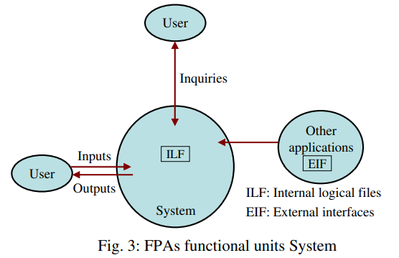

Steps for Function Point Analysis:
  - Identify Function Types:
    - External Inputs (EI): User inputs that affect processing.
    - External Outputs (EO): Outputs generated for the user.
    - External Inquiries (EQ): User interactions that result in queries or data retrieval.
  - Count Complexity Factors:
    - Determine complexity factors (low, average, high) for each function type based on factors like data processing and user interaction.
  - Calculate Unadjusted Function Points:
    - Sum the weighted counts of each function type to get the Unadjusted Function Points (UFP).
  - Apply Complexity Adjustment Factors:
    - Apply complexity adjustment factors to UFP based on the complexity of the project.
  - Calculate Adjusted Function Points (AFP):
    - Adjusted Function Points (AFP) = UFP * Complexity Adjustment Factor.
Function Point Analysis provides a more accurate estimate of software size by considering both the functionality delivered and the complexity involved. It is often used in cost estimation models and helps in planning resources, scheduling, and managing software projects. While both LOC estimation and Function Point Analysis have their uses, Function Point Analysis is generally considered more reliable and accurate, especially for larger and more complex projects.

Ques 2: what are size metrics? How is function point metric advantageous over loc metric explain ?

Size metrics in software engineering are used to quantify the size of a software system or its components. The most common size metrics include:
- Line of Code (KLOC): This measures the size of a software project by counting the number of thousands of lines in the source code.
- Function Points (FP): This measures the functionality delivered by the software by evaluating various aspects such as inputs, outputs, user interactions, and processing complexity.

The main advantage of function points over the size metric of KLOC, the other commonly used approach, is that the definition of AFP depends only on information available from the specifications, whereas the size in KLOC cannot be directly determined from specifications. Furthermore, the AFP count is independent of the language in which the project is implemented. Though these are major advantages, another drawback of the function point approach is that even when the project is finished, the AFP is not uniquely known and has subjectivity. This makes building of models for cost estimation hard, as these models are based on information about completed projects (cost models are discussed further in the next chapter). In addition, determining the AFP—from either the requirements or a completed project—cannot be automated. That is, considerable effort is required to obtain the size, even for a completed project. This is a drawback compared to KLOC measure, as KLOC can be determined uniquely by automated tools once the project is completed.

Ques 3 : describe various types of cococo model

COCOMO (COnstructive COst MOdel): COCOMO is one of the earliest and most widely used cost estimation models. It was introduced by Barry Boehm in the 1980s and has evolved into different versions:
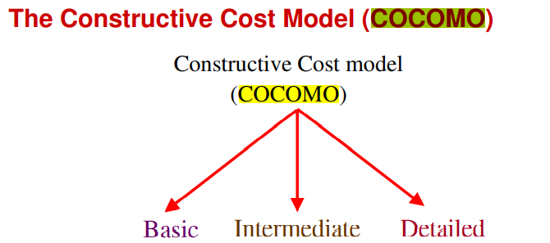

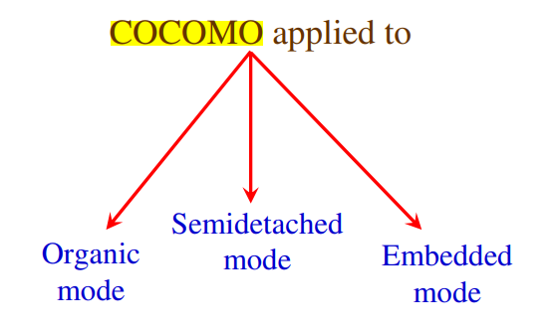

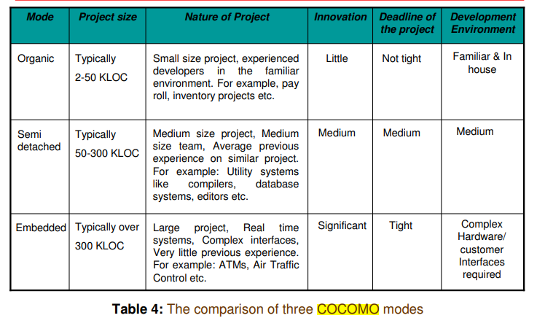

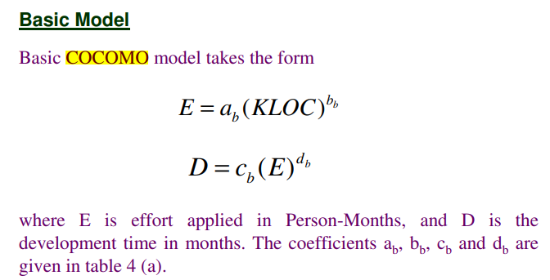
Basic COCOMO is the simplest version of the model and estimates effort and duration based on the size of the project. It is suitable for small to medium-sized projects with straightforward development processes. The formula for estimating effort (E) in personmonths is:

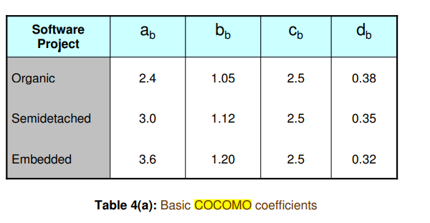

Intermediate COCOMO: Intermediate COCOMO builds upon the basic model by adding a set of 15 cost drivers that account for additional project characteristics and factors affecting effort and cost. These factors include team experience, development environment, complexity, and more. The effort estimation formula becomes:

E = a * (Size) ^ b * EAF Where EAF

(Effort Adjustment Factor) is calculated based on the 15 cost drivers.

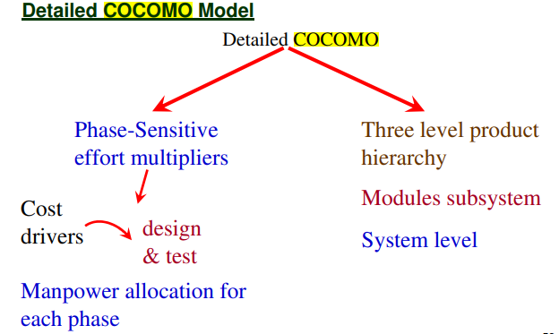

Detailed COCOMO (COCOMO II) further refines the model by introducing a set of 17 cost drivers that provide even more detailed estimation. It takes into account factors such as personnel attributes, reuse, and documentation. The effort estimation formula remains similar to Intermediate COCOMO, but with more refined EAF calculation

Ques4 explain cocomo -2 model in detail .what type of categories of project are identifiable?

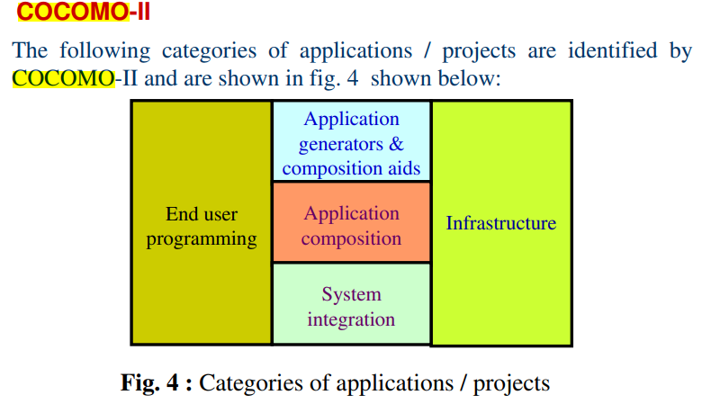
COCOMO has evolved into a more comprehensive estimation model called COCOMO II. Like its predecessor, COCOMO II is a hierarchy of estimation models that address different stages of the software development process. These models include:
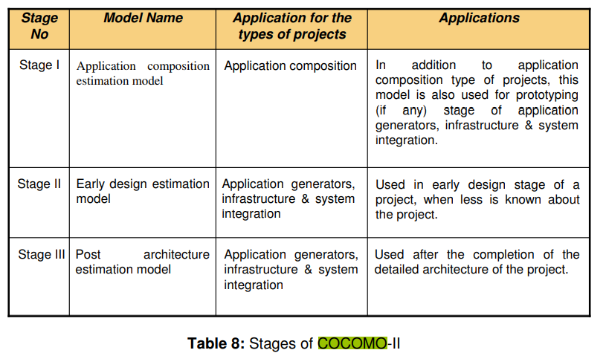
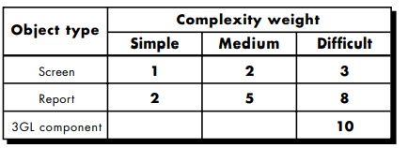
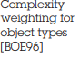

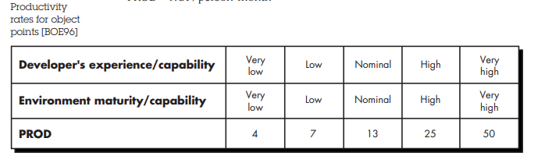

Like all estimation models for software, the COCOMO II models require sizing information. Three sizing options are available: object points, function points (FP), and lines of source code (KLOC).
- Object Points: The COCOMO II application composition model uses object points for estimation. Object points are an indirect measure of software size, calculated by counting the number of user interface screens, reports, and components. These object instances are classified as simple, medium, or difficult based on their complexity, which is determined by the number of data tables and sections involved in generating them.
- Complexity and Weights: The complexity of each object instance is evaluated according to criteria defined by Boehm. Based on its complexity, each screen, report, or component is weighted according to predefined factors, as shown in a weighting table.
- New Object Points (NOP): To adjust for software reuse, the object point count is modified using the formula:
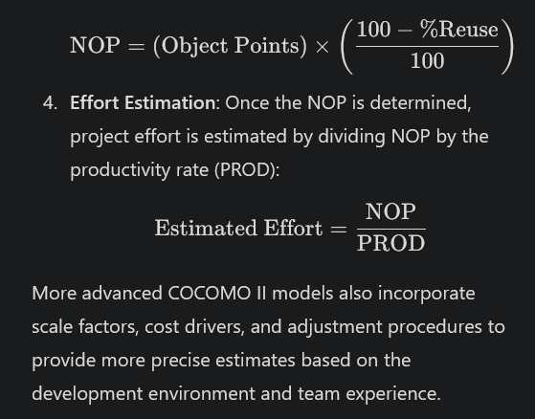

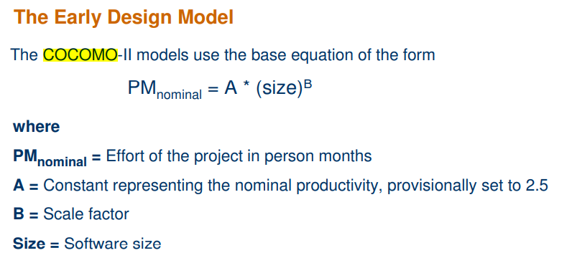

Software engineering assignment 3

Ques 1 : discuss the differences btw object oriented and function oriented design .

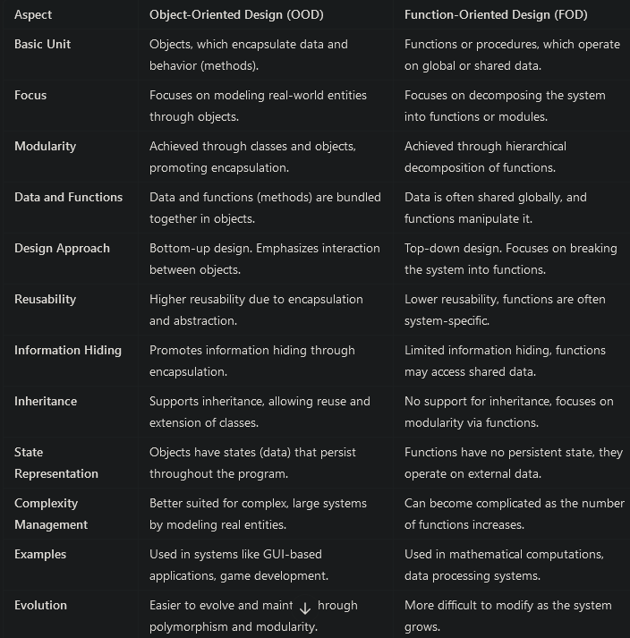
Ques 2 : explain halstead theory of software science
Is it significant in today’s scenario of component based software development?

Halstead's theory of software science [HAL77] is one of "the best known and most thoroughly studied . . . composite measures of (software) complexity" [CUR80]. Software science proposed the first analytical "laws" for computer software.9 Software science assigns quantitative laws to the development of computer software, using a set of primitive measures that may be derived after code is generated or estimated once design is complete. These follow

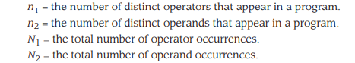

Halstead uses these primitive measures to develop expressions for the overall program length, potential minimum volume for an algorithm, the actual volume (number of bits required to specify a program), the program level (a measure of software complexity), the language level (a constant for a given language), and other features such as development effort, development time, and even the projected number of faults in the software

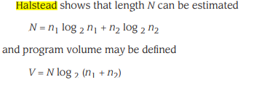

It should be noted that V will vary with programming language and represents the volume of information (in bits) required to specify a program. Theoretically, a minimum volume must exist for a particular algorithm. Halstead defines a volume ratio L as the ratio of volume of the most compact form of a program to the volume of the actual program. In actuality, L must always be less than 1. In terms of primitive measures, the volume ratio may be expressed as

L = 2/n1 * n2/N2

Halstead's work is amenable to experimental verification and a large body of research has been conducted to investigate software science.

In today’s component-based software development, Halstead’s theory still holds some relevance, but its significance has decreased. Modern software engineering focuses heavily on reusability, modularity, and abstraction, especially in object-oriented and component-based systems. Halstead’s theory, which was developed in the context of procedural programming, does not directly address these modern paradigms.
However, the basic principles of complexity measurement from Halstead's theory can still provide insights into certain aspects of code complexity, especially for traditional procedural code or smaller, standalone components.

Ques 3 : define data structure metrics how can we calculate amount of data in a program ?

Essentially the need for software development and other activities are to process data. Some data is input to a system, program or module; some data may be used internally, and some data is the output from a system, program, or module.

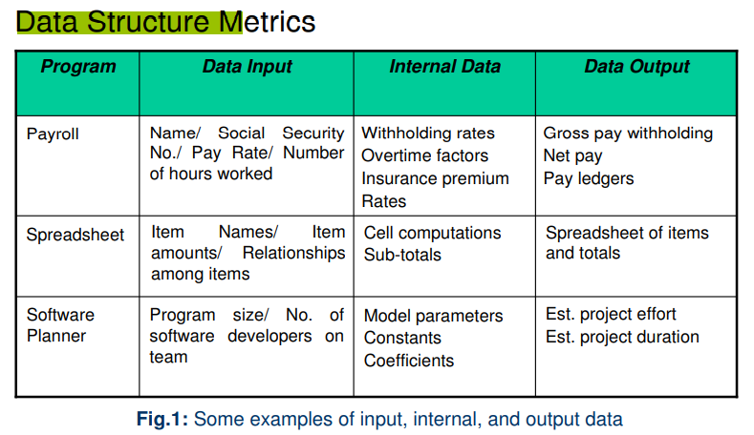

That's why an important set of metrics which capture in the amount of data input, processed in an output form software. A count of this data structure is called Data Structured Metrics. In these concentrations is on variables (and given constant) within each module & ignores the input-output dependencies.
There are some Data Structure metrics to compute the effort and time required to complete the project. There metrics are:
- The Amount of Data.
- The Usage of data within a Module.
- Program weakness.
- The sharing of Data among Modules.

1. The Amount of Data: To measure the amount of Data, there are further many different metrics, and these are:
- Number of variable (VARS): In this metric, the Number of variables used in the program is counted.
- Number of Operands (η2): In this metric, the Number of operands used in the program is counted.
η2 = VARS + Constants + Labels
- Total number of occurrence of the variable (N2): In this metric, the total number of occurrence of the variables are computed

2. The Usage of data within a Module: The measure this metric, the average numbers of live variables are computed. A variable is live from its first to its last references within the procedure.
3. Program weakness: Program weakness depends on its Modules weakness. If Modules are weak(less Cohesive), then it increases the effort and time metrics required to complete the project.
Module Weakness (WM) = LV* γ
A program is normally a combination of various modules; hence, program weakness can be a useful measure and is defined as:
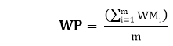
Where
WMi: Weakness of the ith module
WP: Weakness of the program
m: No of modules in the program
4. There Sharing of Data among Module: As the data sharing between the Modules increases (higher Coupling), no parameter passing between Modules also increased, As a result, more effort and time are required to complete the project. So Sharing Data among Module is an important metrics to calculate effort and time.

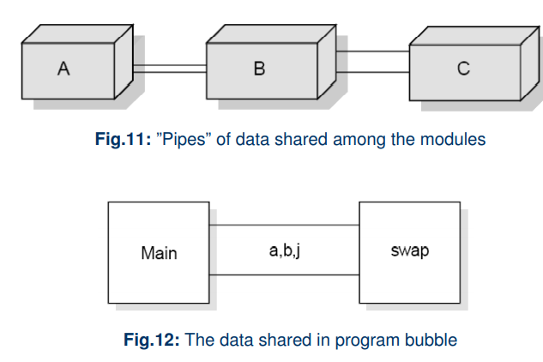

Ques 4 : discuss object oriented metrics what is the importance of metrics in obejct oriented
software development?

Object-Oriented (OO) Metrics are used to measure various aspects of object-oriented software development, such as design quality, complexity, maintainability, and performance. These metrics help in assessing the effectiveness of OO techniques like classes, inheritance, and encapsulation.

Size Metrics:
- Number of Methods per Class (NOM): Counts the total methods in a class.
- Number of Attributes per Class (NOA): Counts the total attributes in a class.
- Weighted Number of Methods per Class (WMC): Measures the complexity by summing the complexities of all methods in a class.

Coupling Metrics:
- Response for a Class (RFC): Measures the number of methods (internal and external) that can be executed in response to a message to an object.
- Data Abstraction Coupling (DAC): Counts the number of abstract data types in a class.
- Message Passing Coupling (MPC): Counts the number of send statements (messages) in a class.
- Coupling Factor (CF): Ratio of actual coupling to the maximum possible coupling in the system.
- Coupling Between Objects (CBO): Measures the number of classes to which a particular class is coupled.

Cohesion Metrics:
- Lack of Cohesion in Methods (LCOM): Measures how closely the methods in a class are related to each other.
- Tight Class Cohesion (TCC): Percentage of pairs of public methods that share common attributes.
- Loose Class Cohesion (LCC): Similar to TCC but also considers indirectly connected methods.
- Information-based Cohesion (ICH): Measures the number of invocations between methods of the same class, weighted by the number of parameters of the invoked methods.

Inheritance Metrics:
- Depth of Inheritance Tree (DIT): The level of a class in the inheritance hierarchy.
- Number of Children (NOC): The number of immediate subclasses of a class.
- Attribute Inheritance Factor (AIF): The ratio of inherited attributes to total attributes in a class.
- Method Inheritance Factor (MIF): The ratio of inherited methods to the total number of methods in a class system.
Importance of metrics in object-oriented software development:
- Quality Assurance: Evaluate code and design quality.
- Project Management: Assist in estimating timelines and resource allocation.
- Performance Evaluation: Gauge component performance for optimization.
- Maintainability: Identify complex or tightly coupled classes for refactoring.
- Cost Estimation: Provide data for better development cost estimates.
- Risk Management: Identify high-risk areas for proactive mitigation.
Ques 5 .explain the basic and logarithmic poision model and there significance in reliabilty studies?

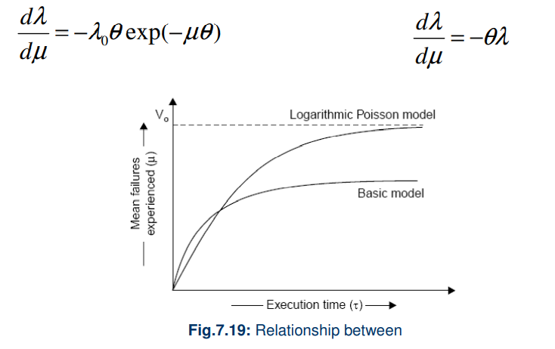

Basic Poisson Model
Description:
- The basic Poisson model assumes that events (e.g., system failures) occur randomly and independently over time. It is characterized by a single parameter, λ (lambda), which represents the average rate of occurrence (mean number of events in a specified interval).
- The probability of observing kkk events in a time interval ttt is given by the formula:
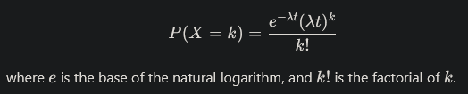

Significance in Reliability Studies:
- Failure Rate Estimation: The basic Poisson model helps estimate the failure rate of systems, enabling organizations to understand how often failures are likely to occur.
- Reliability Prediction: It allows for predicting system reliability over time by modeling how the failure rate may change with time or usage.
- Maintenance Planning: By understanding failure patterns, organizations can optimize maintenance schedules and resource allocation, reducing downtime and costs.

Logarithmic Poisson Model

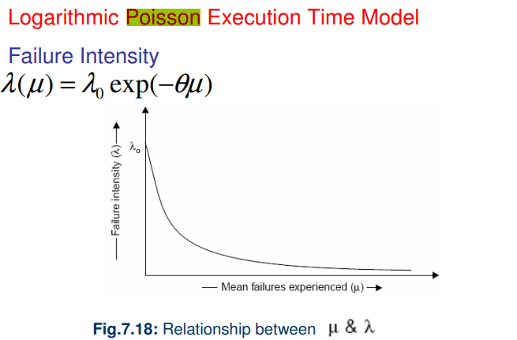
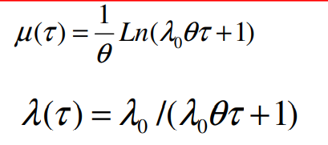

Using statistical modeling and software reliability theory, models of software failures (uncovered during testing) as a function of execution time can be developed [MUS89]. A version of the failure model, called a logarithmic Poisson execution-time model, takes the form:

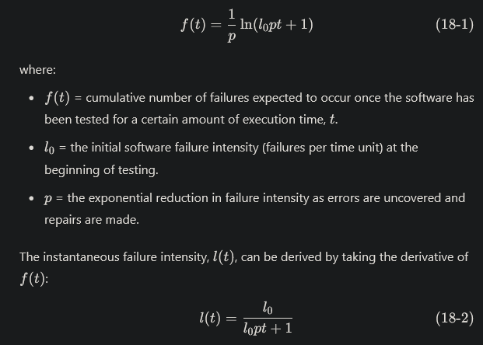
Using the relationship noted in Equation (18-2), testers can predict the drop-off of errors as testing progresses. The actual error intensity can be plotted against the predicted curve (Figure 18.3). If the actual data gathered during testing and the logarithmic Poisson execution time model are reasonably close to one another over a number of data points, the model can be used to predict the total testing time required to achieve an acceptably low failure intensity.

Software engineering
Assignment 4
Ques 1 discuss structure testing how is it different from functional testing

Definition of Structural Testing
Structural testing is a type of software testing that tests the internal code structure of the software. It verifies what happens inside the system and is also referred to as white-box or clear-box testing.
This type of testing requires good knowledge of the programming language and the code’s internal implementation. It is based on how the system functions rather than the business requirements.

Different Types of Structural Testing Techniques
- Mutation – A small change in the source code is made to test if the test cases can detect the changes. It is also called fault-based testing, as the fault is intentionally created in the code.
- Control flow – This type of structural testing uses the program’s control flow as a model. Complete knowledge of the structure, design, and code of the software is necessary for this type of testing.
- Data flow – Data flow testing depends on data values and uses control flow graphs to identify any bugs that can interrupt data flow.

Functional testing is software testing that checks the functionality of the software application as per the requirement specification. It validates the output against the given input.
Functional testing aims to check the necessary usable function, input validation, and functional completeness. It is concerned with user experience and application function rather than the coding aspects.

Structural Testing | Functional Testing
This test evaluates the code structure or internal implementation of the code. | This test checks whether the software is functioning in accordance with functional requirements and specifications.
It is also known as white-box or clear-box testing as thorough knowledge and access of the code is required. | It is also known as black-box testing as no knowledge of the internal code is required.
Finds errors in the internal code logic and data structure usage. | It ensures that the system is error-free.
It does not ensure that the user requirements are met. | It is a quality assurance testing process ensuring the business requirements are met.
Performed the entire software in accordance with the system requirements. | Functional testing checks that the output is given as per expected.
Testing teams usually require developers to perform structural testing. | A QA professional can simply perform this testing.
Perform on low-level modules/software components. | The functional testing tool works on event analysis methodology.
It provides information on improving the internal structure of the application. | It provides information that prevents business loss.
Structural testing tools follow data analysis methodology. | Functional testing tool works on event analysis methodology.
Writing a structural test case requires understanding the coding aspects of the application. | Before writing a functional test case, a tester is required to understand the application’s requirements.
It examines how well modules communicate with one another. | It examines how well a system satisfies the business needs or the SRS.

Ques2: differntitae bw integration testing and system testing

System Testing | Integration Testing
In system testing, we check the system as a whole. | In integration testing, we check the interfacing between the inter-connected components.
It is performed after integration testing. | It is performed after unit testing.
It is carried out for performing both functional and non-functional testing(performance, usability, etc). | It is generally limited to functional aspects of the integrated components.
Since the testing is limited to the evaluation of functional requirements, hence, it includes black-box testing techniques only. | Since the interfacing logic is required to perform this testing, hence, it requires white/grey box testing techniques along with black-box techniques.
The different types of system testing are- Functional testing, Performance testing, Usability testing, Reliability testing, Security testing, Scalability testing, Installation testing, etc. | The different approaches of performing integration testing namely – Top-down, bottom-up, big-bang and hybrid integration.

Ques 3 what are the various debugging approaches

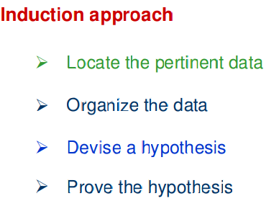

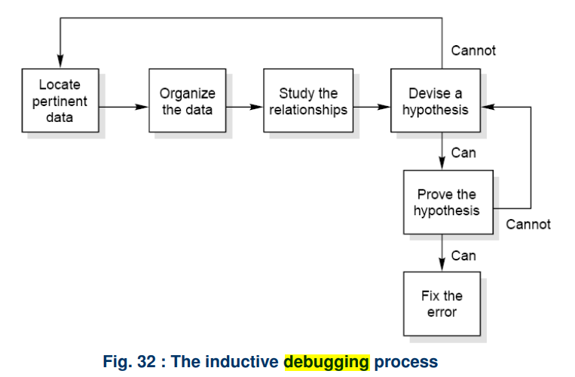

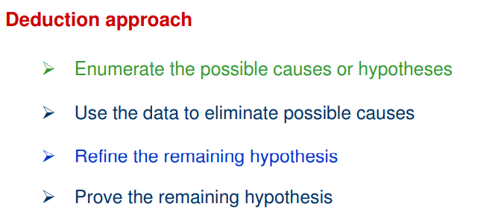
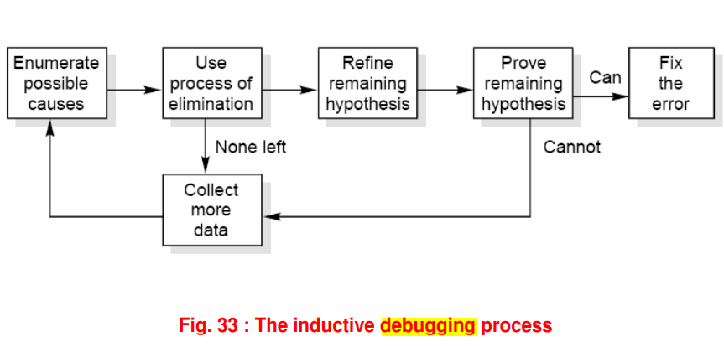

Ques 4 : describe various maintenance cost estimation models

Belady and Lehman Model
The Belady and Lehman Model, proposed by Mehdi Belady and Mario M. Lehman, focuses on understanding software evolution and its impact on maintenance costs. This model emphasizes the relationship between software changes and various factors influencing these changes.

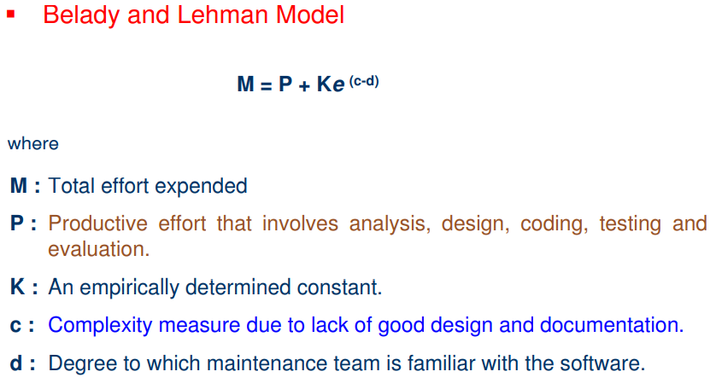

Boehm Model
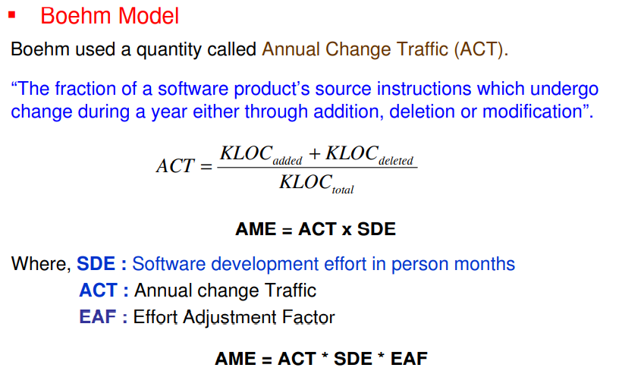
The Boehm Model, developed by Barry Boehm, focuses on software cost estimation, particularly maintenance costs. One of its key components is the Annual Change Traffic (ACT) metric, which helps estimate the effort required for maintenance based on the frequency and nature of changes. Important elements include:

Ques 5 : what is regression testing differentiate bw regression and development testing

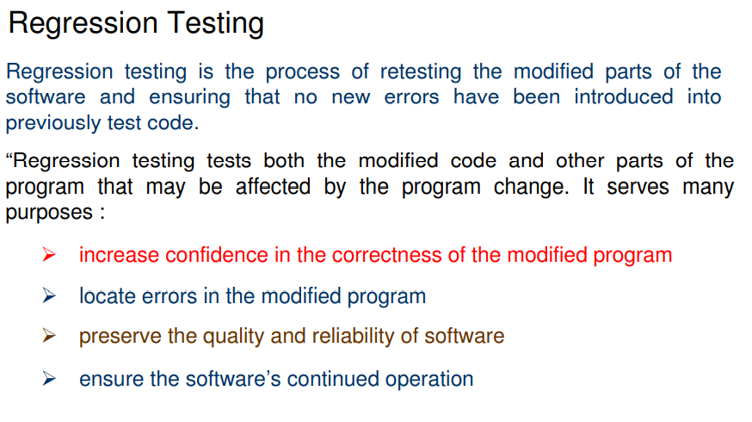

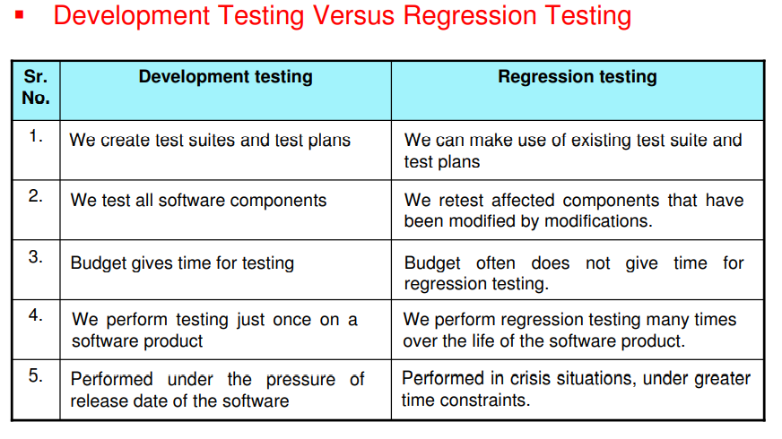

Ques6 : Discuss what is reverse engineering and reengineering discuss ?

Reverse Engineering:

Reverse engineering is the process followed in order to find difficult, unknown and hidden information about a software system

Reverse Engineering encompasses a wide array of tasks related to understanding and modifying software system. This array of tasks can be broken into a number of classes

Reverse engineering can extract design information from source code, but the abstraction level, the completeness of the documentation, the degree to which tools and a human analyst work together, and the directionality of the process are highly variable [CAS88]. The abstraction level of a reverse engineering process and the tools used to effect it refers to the sophistication of the design information that can be extracted from source code. Ideally, the abstraction level should be as high as possible. That is, the reverse engineering

The reverse engineering process is represented in Figure 30.3. Before reverse engineering activities can commence, unstructured (“dirty”) source code is restructured (Section 30.4.1) so that it contains only the structured programming constructs.2 This makes the source code easier to read and provides the basis for all the subsequent reverse engineering activities. The core of reverse engineering is an activity called extract abstractions. The engineer must evaluate the old program and from the (often undocumented) source code, extract a meaningful specification of the processing that is performed, the user interface that is applied, and the program data structures or database that is used.

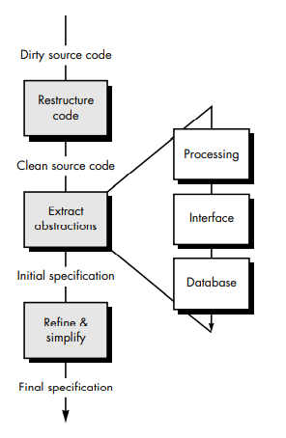

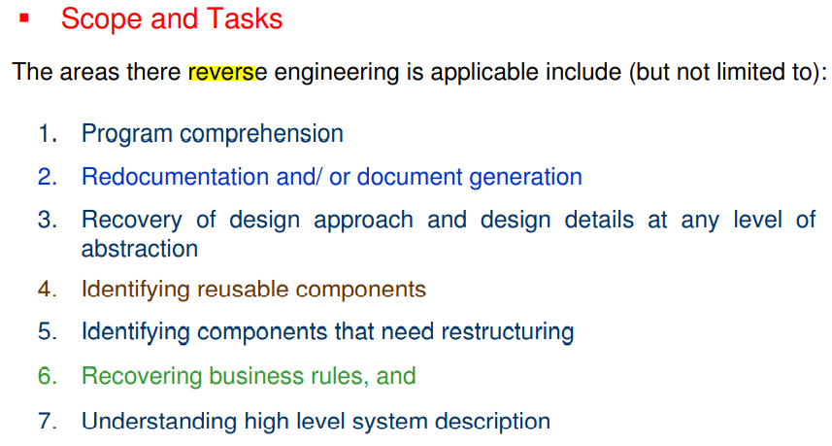
Levels of Reverse Engineering

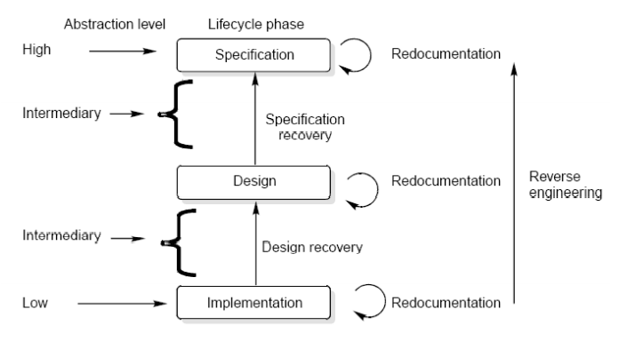
Reverse Engineers detect low level implementation constructs and replace them with their high level counterparts. The process eventually results in an incremental formation of an overall architecture of the program.

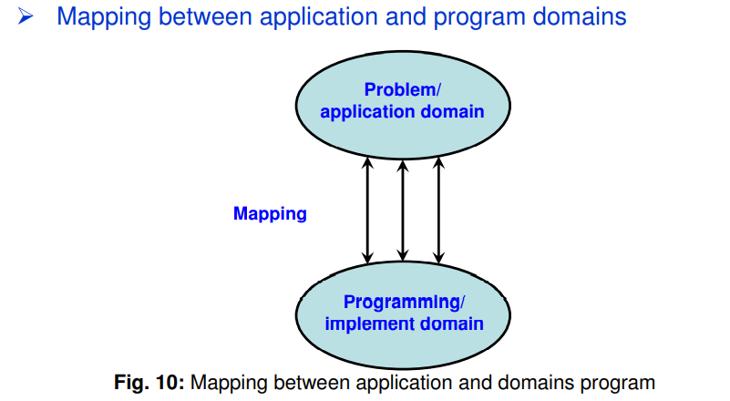
Redocumentation

Redocumentation is the recreation of a semantically equivalent representation within the same relative abstraction level.

Design recovery

Design recovery entails identifying and extracting meaningful higher level abstractions beyond those obtained directly from examination of the source code. This may be achieved from a combination of code, existing design documentation, personal experience, and knowledge of the problem and application domains.

Software RE-Engineering

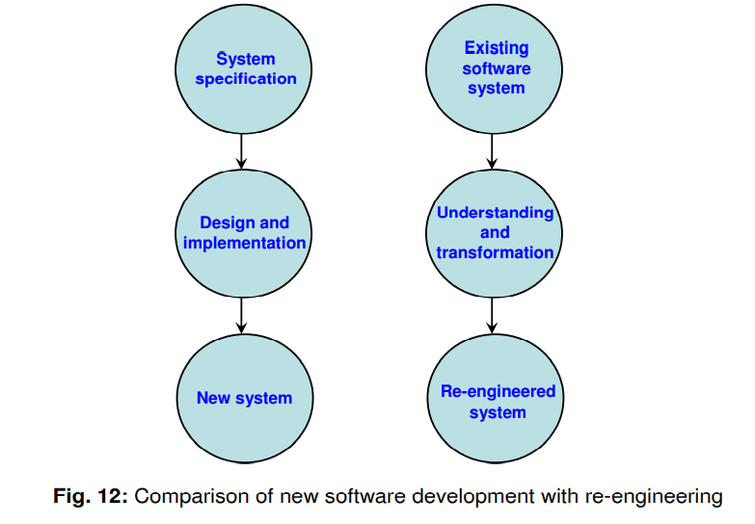

Software Re-engineering
Software re-engineering is concerned with taking existing legacy systems and re-implementing them to make them more maintainable. The critical distinction between re-engineering and new software development is the starting point for the development, as shown in Figure 12.
Best Practices for Software Maintenance
To effectively maintain and re-engineer legacy systems, the following suggestions may be useful:
- Study Code Well Before Attempting Changes:
  - Thoroughly understanding the existing codebase helps avoid introducing new bugs during modifications.
- Concentrate on Overall Control Flow and Not Coding:
  - Focus on the overall structure and logic of the software to ensure that changes align with the intended functionality.
- Heavily Comment Internal Code:
  - Detailed comments enhance code readability and provide context, facilitating easier understanding for future maintainers.
- Create Cross References:
  - Cross-referencing related code segments helps developers understand dependencies and interactions within the system.
- Build Symbol Tables:
  - Symbol tables assist in tracking variable definitions and scopes, making it easier to manage complex variable usage.
- Use Own Variables, Constants, and Declarations to Localize the Effect:
  - Defining well-scoped variables reduces the risk of unintended side effects from changes.
- Keep Detailed Maintenance Documents:
  - Comprehensive documentation of maintenance activities provides historical context and aids future maintenance efforts.

